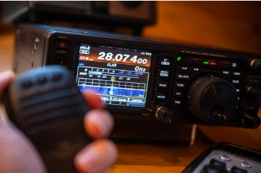
General Class License Course
The Western Mass Train and Test Group will be having a General Class License course beginning on June 2 on Zoom.
Class meets Tuesdays and Thursdays from 7-9 PM for 6 weeks.
This is a free course, but you need to purchase the ARRL General Class Manual for your study guide.
**Email Ray Lajoie at ray.aa1se@gmail.com with questions** **To register go to: https://forms.gle/DuvE1duskwLcJK8M6
Upgrade your license to talk to the world and make friends! Learn new technologies. Volunteer for public service. Great for STEM Learning! Join us!
Get your General Class License Now!

